# Troubleshooting

## Kubernetes cluster

Troubleshooting the control plane

Listing the nodes in a cluster

First thing to check if your cluster is working fine or not is to list the nodes associated with your cluster.

kubectl **get** nodes

Make sure that all nodes are in Ready state.

List the control plane pods

If your nodes are up and running, the next thing to check is the status of Kubernetes components. Run,

kubectl **get** pods -n kube-system

If any of the pods are *restarting or crashing*, look into the issue. This can be done by getting the pod's description. For example, in my cluster *kube-dns* is crashing. In order to fix this first check the deployment for errors.

kubectl **describe** deployment -n kube-**system** coredns

Log files

Master

If your deployment is good, the next thing to look for is log files. The locations of log files are given below...

/var/log/pod/kube-apiserver - For API Server logs

/var/log/pod/kube-scheduler - For Scheduler logs

/var/log/pod/kube-controller-manager - For Controller logs

Worker Nodes

In your worker, you will need to check for errors in kubelet's log...

sudo journalctl -u kubelet

sudo service kubelet status

If not running,

## sudo service kubelet restart

## 2-Tier App

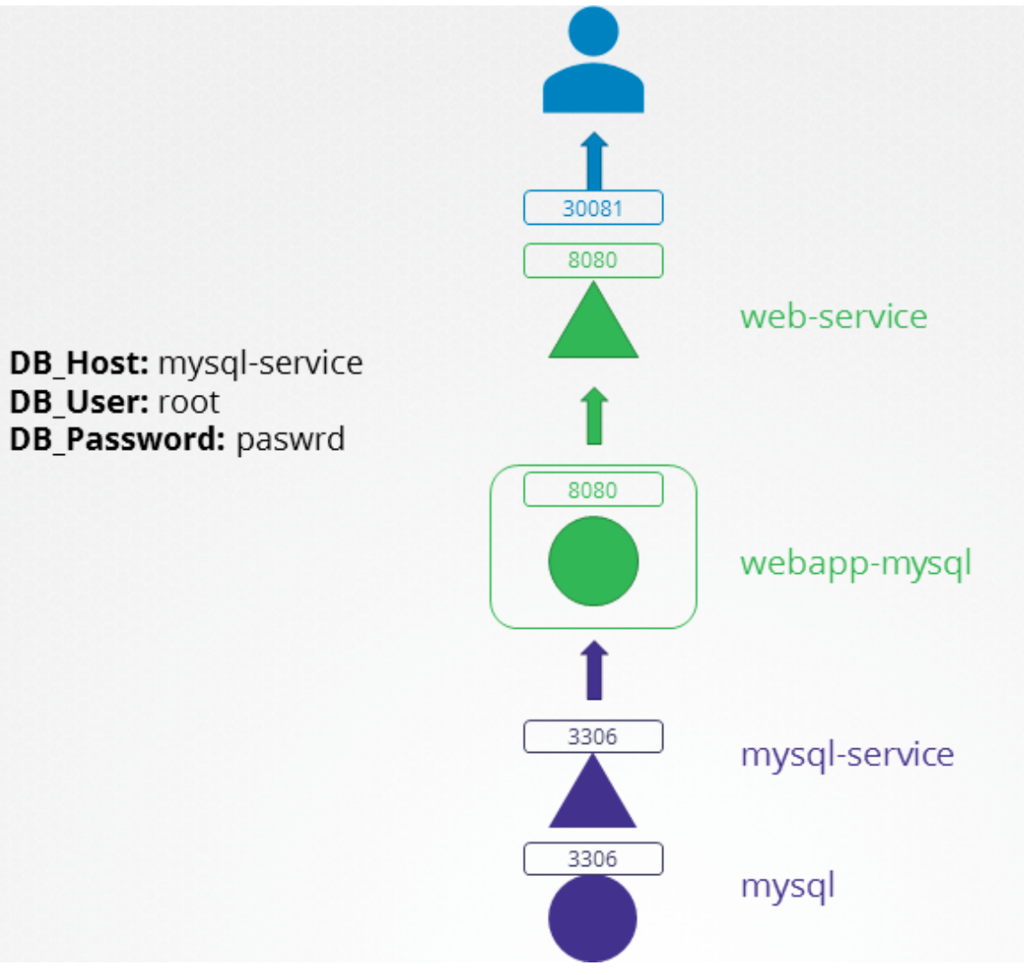

Access the app url - http://localhost:30081 for troubleshooting

k create ns alpha

k apply -f ex1

k get all -n alpha

curl <http://localhost:30081>

<!-- <h1> Failed connecting to the MySQL database. </h1> -->

Ex 1:

apiVersion: v1

kind: Pod

metadata:

labels:

name: mysql

name: mysql

namespace: alpha

spec:

containers:

- env:

- name: MYSQL_ROOT_PASSWORD

value: paswrd

image: mysql:5.6

imagePullPolicy: IfNotPresent

name: mysql

ports:

- containerPort: 3306

protocol: TCP

---

apiVersion: v1

kind: Service

metadata:

name: mysql

namespace: alpha

spec:

ports:

- port: 3306

targetPort: 3306

selector:

name: mysql

---

apiVersion: apps/v1

kind: Deployment

metadata:

labels:

name: webapp-mysql

name: webapp-mysql

namespace: alpha

spec:

replicas: 1

selector:

matchLabels:

name: webapp-mysql

template:

metadata:

labels:

name: webapp-mysql

name: webapp-mysql

spec:

containers:

- env:

- name: DB_Host

value: mysql-service

- name: DB_User

value: root

- name: DB_Password

value: paswrd

image: mmumshad/simple-webapp-mysql

imagePullPolicy: Always

name: webapp-mysql

ports:

- containerPort: 8080

protocol: TCP

---

apiVersion: v1

kind: Service

metadata:

name: web-service

namespace: alpha

spec:

ports:

- port: 8080

targetPort: 8080

nodePort: 30081

selector:

name: webapp-mysql

type: NodePort

Ex2:

apiVersion: v1

kind: Pod

metadata:

labels:

name: mysql

name: mysql

namespace: alpha

spec:

containers:

- env:

- name: MYSQL_ROOT_PASSWORD

value: paswrd

image: mysql:5.6

imagePullPolicy: IfNotPresent

name: mysql

ports:

- containerPort: 3306

protocol: TCP

---

apiVersion: v1

kind: Service

metadata:

name: mysql-service

namespace: alpha

spec:

ports:

- port: 3306

targetPort: 8080

selector:

name: mysql-db

---

apiVersion: apps/v1

kind: Deployment

metadata:

labels:

name: webapp-mysql

name: webapp-mysql

namespace: alpha

spec:

replicas: 1

selector:

matchLabels:

name: webapp-mysql

template:

metadata:

labels:

name: webapp-mysql

name: webapp-mysql

spec:

containers:

- env:

- name: DB_Host

value: mysql-service

- name: DB_User

value: root

- name: DB_Password

value: paswrd

image: mmumshad/simple-webapp-mysql

imagePullPolicy: Always

name: webapp-mysql

ports:

- containerPort: 8080

protocol: TCP

---

apiVersion: v1

kind: Service

metadata:

name: web-service

namespace: alpha

spec:

ports:

- port: 8080

targetPort: 8080

nodePort: 30081

selector:

name: webapp-mysql

type: NodePort

**EX3:**

apiVersion: v1

kind: Pod

metadata:

labels:

name: mysql

name: mysql

namespace: alpha

spec:

containers:

- env:

- name: MYSQL_ROOT_PASSWORD

value: password

image: mysql:5.6

imagePullPolicy: IfNotPresent

name: mysql

ports:

- containerPort: 3306

protocol: TCP

---

apiVersion: v1

kind: Service

metadata:

name: mysql-service

namespace: alpha

spec:

ports:

- port: 3306

targetPort: 3306

selector:

name: mysql

---

apiVersion: apps/v1

kind: Deployment

metadata:

labels:

name: webapp-mysql

name: webapp-mysql

namespace: alpha

spec:

replicas: 1

selector:

matchLabels:

name: webapp-mysql

template:

metadata:

labels:

name: webapp-mysql

name: webapp-mysql

spec:

containers:

- env:

- name: DB_Host

value: mysql-service

- name: DB_User

value: sql-user

- name: DB_Password

value: paswrd

image: mmumshad/simple-webapp-mysql

imagePullPolicy: Always

name: webapp-mysql

ports:

- containerPort: 8080

protocol: TCP

---

apiVersion: v1

kind: Service

metadata:

name: web-service

namespace: alpha

spec:

ports:

- port: 8080

targetPort: 8080

nodePort: 30081

selector:

name: webapp-mysql

type: NodePort

Ex4:

apiVersion: v1

kind: Pod

metadata:

labels:

name: mysql

name: mysql

namespace: ex2

spec:

containers:

- env:

- name: MYSQL_ROOT_PASSWORD

value: paswrd

image: mysql:5.6

imagePullPolicy: IfNotPresent

name: mysql

ports:

- containerPort: 3306

protocol: TCP

---

apiVersion: v1

kind: Service

metadata:

name: mysql-service

namespace: ex2

spec:

ports:

- port: 3306

targetPort: 8080

selector:

name: mysql-db

---

apiVersion: apps/v1

kind: Deployment

metadata:

labels:

name: webapp-mysql

name: webapp-mysql

namespace: ex2

spec:

replicas: 1

selector:

matchLabels:

name: webapp-mysql

template:

metadata:

labels:

name: webapp-mysql

name: webapp-mysql

spec:

containers:

- env:

- name: DB_Host

value: mysql-svc

- name: DB_User

value: root

- name: DB_Password

value: paswrd

image: mmumshad/simple-webapp-mysql

imagePullPolicy: Always

name: webapp-mysql

ports:

- containerPort: 8080

protocol: TCP

---

apiVersion: v1

kind: Service

metadata:

name: web-service

namespace: ex2

spec:

ports:

- port: 8080

targetPort: 8088

nodePort: 30081

selector:

name: webapp-mysql

type: NodePort

**Solution:**

apiVersion: v1

kind: Pod

metadata:

labels:

name: mysql

name: mysql

namespace: alpha

spec:

containers:

- env:

- name: MYSQL_ROOT_PASSWORD

value: paswrd

image: mysql:5.6

imagePullPolicy: IfNotPresent

name: mysql

ports:

- containerPort: 3306

protocol: TCP

---

apiVersion: v1

kind: Service

metadata:

name: mysql-service

namespace: alpha

spec:

ports:

- port: 3306

targetPort: 3306

selector:

name: mysql

---

apiVersion: apps/v1

kind: Deployment

metadata:

labels:

name: webapp-mysql

name: webapp-mysql

namespace: alpha

spec:

replicas: 1

selector:

matchLabels:

name: webapp-mysql

template:

metadata:

labels:

name: webapp-mysql

name: webapp-mysql

spec:

containers:

- env:

- name: DB_Host

value: mysql-service

- name: DB_User

value: root

- name: DB_Password

value: paswrd

image: mmumshad/simple-webapp-mysql

imagePullPolicy: Always

name: webapp-mysql

ports:

- containerPort: 8080

protocol: TCP

---

apiVersion: v1

kind: Service

metadata:

name: web-service

namespace: alpha

spec:

ports:

- port: 8080

targetPort: 8080

nodePort: 30081

selector:

name: webapp-mysql

type: NodePort